**Exercise 1: Mocking and Stubbing**

**Scenario:**

You need to test a service that depends on an external API. Use Mockito to mock the external API and stub its methods.

**Code:**

1. **ExternalApiTest.java**

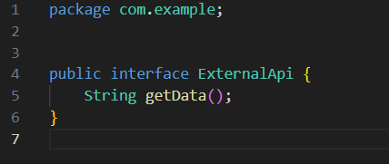

1. **MyService.java**

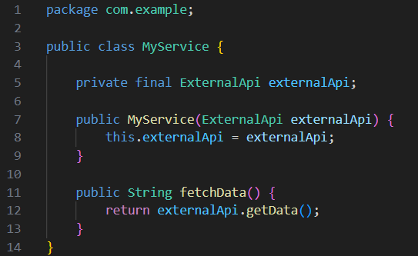

1. **MyServiceTest.java**

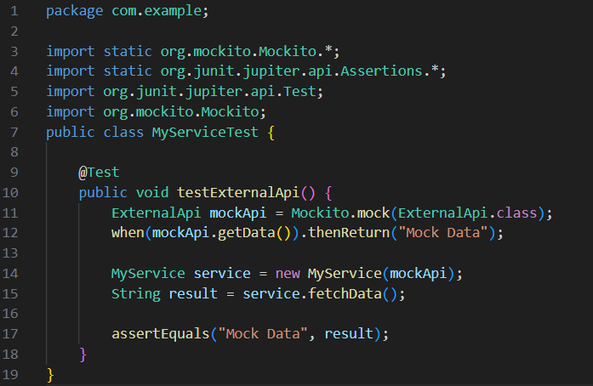

**Output:**

